**Unit-2**

Polish Notations

The way to write arithmetic expression is known as a notation. An arithmetic expression can be written in three different but equivalent notations, i.e., without changing the essence or output of an expression. These notations are −

* Infix Notation
* Prefix (Polish) Notation
* Postfix (Reverse-Polish) Notation
* Infix Notation
* We write expression in **infix** notation, e.g. a - b + c, where operators are used **in**-between operands. It is easy for us humans to read, write, and speak in infix notation but the same does not go well with computing devices. An algorithm to process infix notation could be difficult and costly in terms of time and space consumption.
* Prefix Notation
* In this notation, operator is **prefix**ed to operands, i.e. operator is written ahead of operands. For example, **+ab**. This is equivalent to its infix notation **a + b**. Prefix notation is also known as **Polish Notation**.
* Postfix Notation
* This notation style is known as **Reversed Polish Notation**. In this notation style, the operator is **postfix**ed to the operands i.e., the operator is written after the operands. For example, **ab+**. This is equivalent to its infix notation **a + b**.

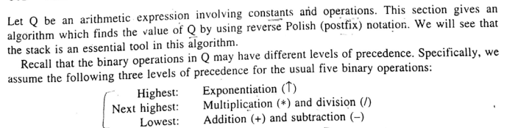

**Postfix expression evaluation**

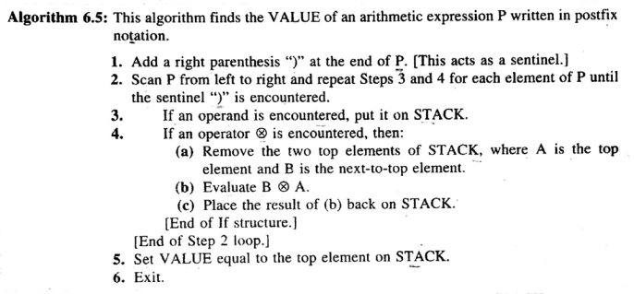

Example:

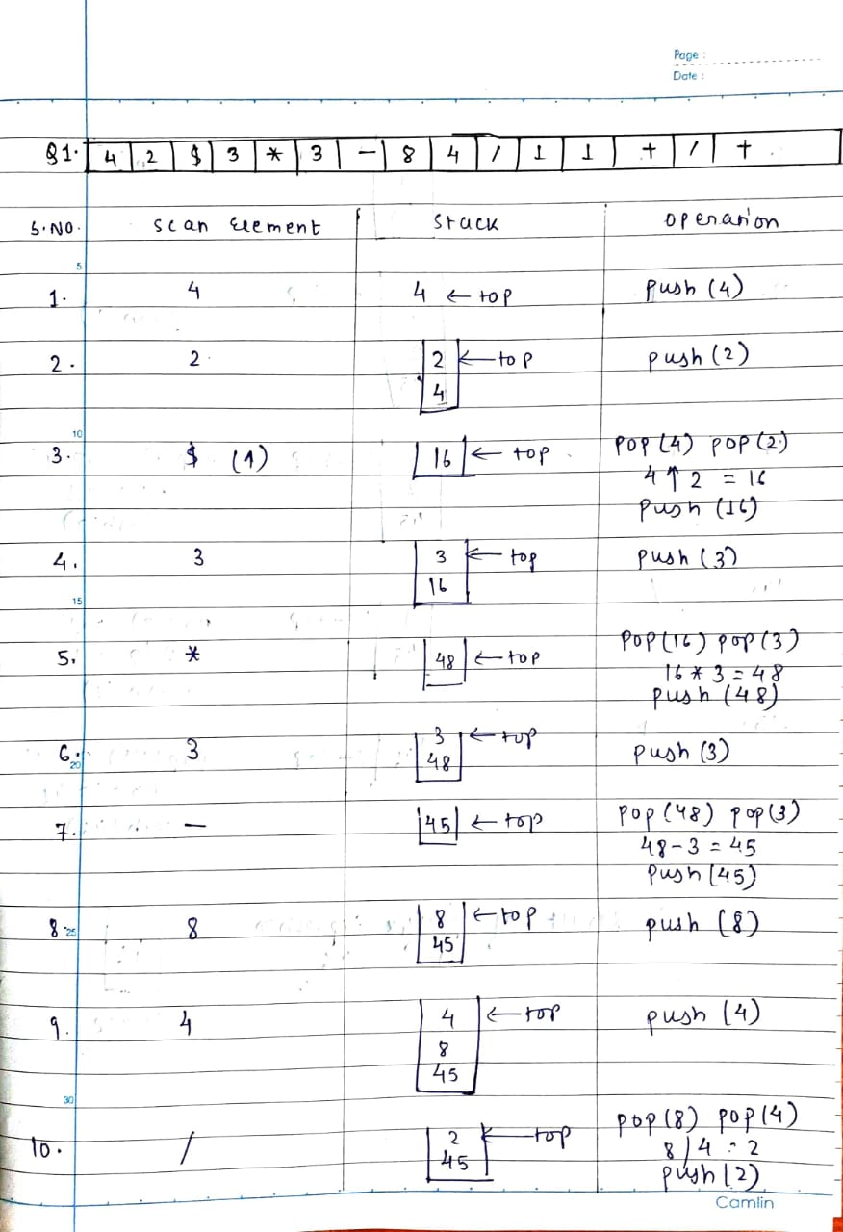

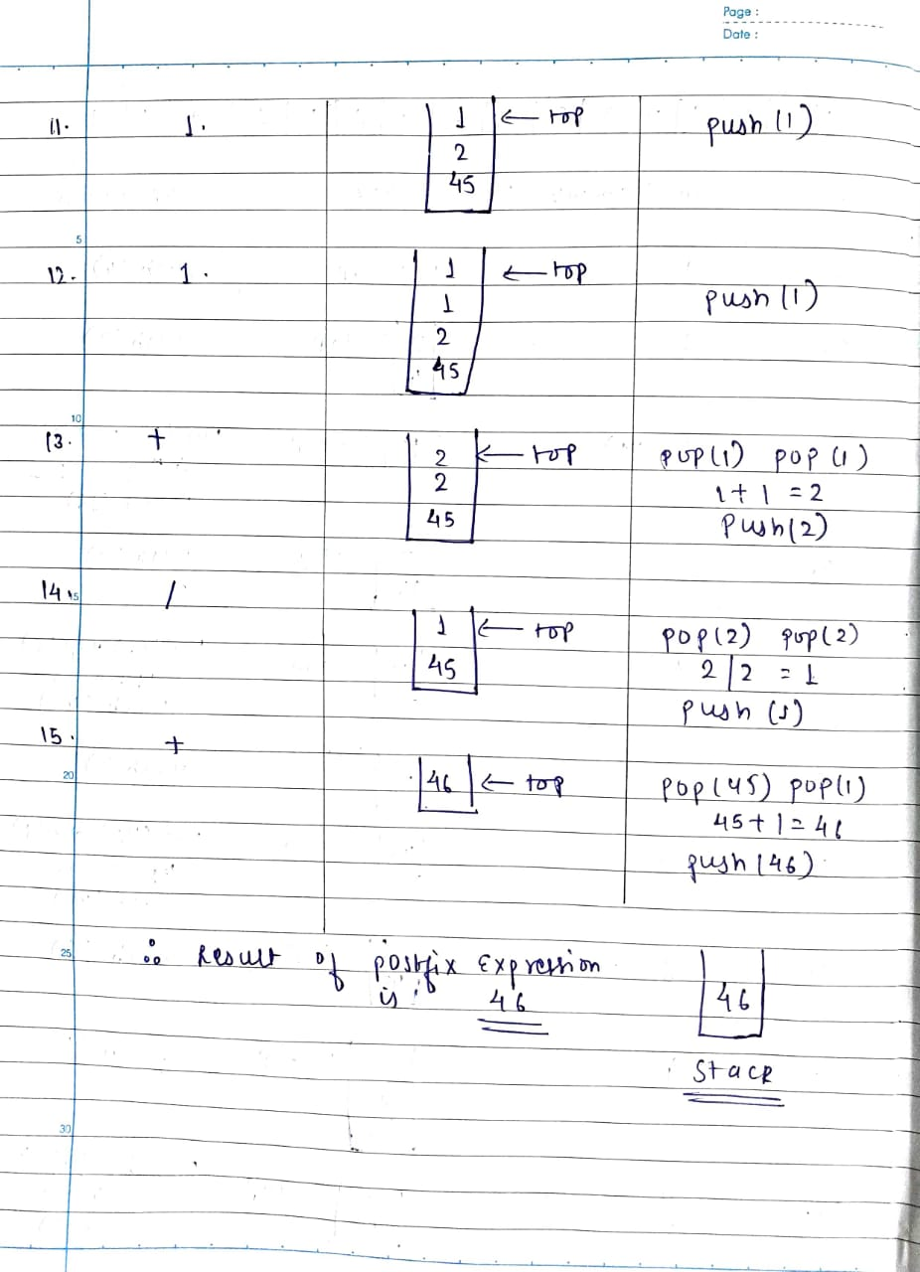

Ex.2

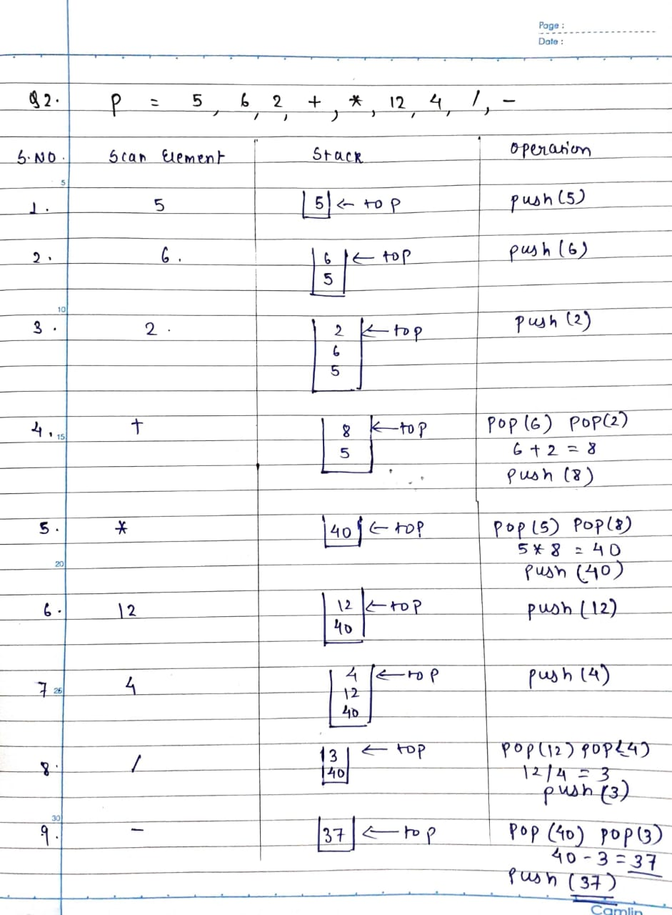

30-09-2020

